Tunisia

## Population Data

The data set shows the political stability estimate of the country each year.

## # A tibble: 23 x 5  
## country iso3c date population popCategory5  
## <chr> <chr> <dbl> <dbl> <chr>   
## 1 Tunisia TUN 1996 9267340 small   
## 2 Tunisia TUN 1997 9395123 small   
## 3 Tunisia TUN 1998 9509857 small   
## 4 Tunisia TUN 1999 9613588 small   
## 5 Tunisia TUN 2000 9708350 small   
## 6 Tunisia TUN 2001 9793903 small   
## 7 Tunisia TUN 2002 9871251 small   
## 8 Tunisia TUN 2003 9945277 small   
## 9 Tunisia TUN 2004 10022277 small   
## 10 Tunisia TUN 2005 10106771 small   
## 11 Tunisia TUN 2006 10201214 small   
## 12 Tunisia TUN 2007 10304726 small   
## 13 Tunisia TUN 2008 10414433 small   
## 14 Tunisia TUN 2009 10525694 small   
## 15 Tunisia TUN 2010 10635244 small   
## 16 Tunisia TUN 2011 10741880 small   
## 17 Tunisia TUN 2012 10847002 small   
## 18 Tunisia TUN 2013 10952951 small   
## 19 Tunisia TUN 2014 11063201 small   
## 20 Tunisia TUN 2015 11179949 small   
## 21 Tunisia TUN 2016 11303946 small   
## 22 Tunisia TUN 2017 11433443 small   
## 23 Tunisia TUN 2018 11565204 small

# Population growth data

## # A tibble: 23 x 5  
## country iso3c date popGrowth popGrowthCat5   
## <chr> <chr> <dbl> <dbl> <chr>   
## 1 Tunisia TUN 1996 1.54 moderate growth rate  
## 2 Tunisia TUN 1997 1.37 slow growth rate   
## 3 Tunisia TUN 1998 1.21 slow growth rate   
## 4 Tunisia TUN 1999 1.08 slow growth rate   
## 5 Tunisia TUN 2000 0.981 slow growth rate   
## 6 Tunisia TUN 2001 0.877 slow growth rate   
## 7 Tunisia TUN 2002 0.787 slow growth rate   
## 8 Tunisia TUN 2003 0.747 slow growth rate   
## 9 Tunisia TUN 2004 0.771 slow growth rate   
## 10 Tunisia TUN 2005 0.840 slow growth rate   
## 11 Tunisia TUN 2006 0.930 slow growth rate   
## 12 Tunisia TUN 2007 1.01 slow growth rate   
## 13 Tunisia TUN 2008 1.06 slow growth rate   
## 14 Tunisia TUN 2009 1.06 slow growth rate   
## 15 Tunisia TUN 2010 1.04 slow growth rate   
## 16 Tunisia TUN 2011 0.998 slow growth rate   
## 17 Tunisia TUN 2012 0.974 slow growth rate   
## 18 Tunisia TUN 2013 0.972 slow growth rate   
## 19 Tunisia TUN 2014 1.00 slow growth rate   
## 20 Tunisia TUN 2015 1.05 slow growth rate   
## 21 Tunisia TUN 2016 1.10 slow growth rate   
## 22 Tunisia TUN 2017 1.14 slow growth rate   
## 23 Tunisia TUN 2018 1.15 slow growth rate

## Population trend

The plot shows the population trend of the country.

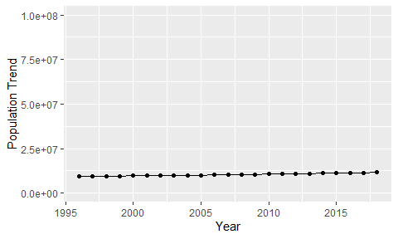

Political Stability Trend

# Population growth trend

The plot shows the population growth rate trend of the country.

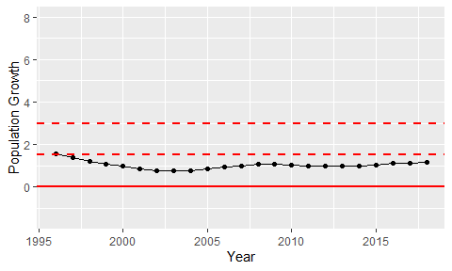

Population Growth Trend